Name: ________________________________ Period: _____
8th Grade: Active or Passive Voice Worksheet 2A
First, box the prepositional phrases! Remember, subjects and verbs will not be in the PP.
Label subject and verb(s). Write on the line if sentence is in Passive or Active Voice.
“by a zombie” after AV = PASSIVE
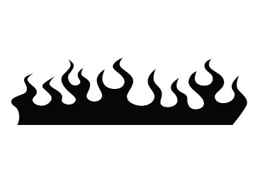
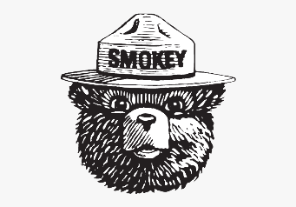
- Forest fires consume trees and other vegetation. ___
- Many animals are killed by the raging flames. ___
- But a fire’s destruction clears the way for new life. ___
- Small trees and sickly trees have been incinerated by the fire. ___
- Strong, healthy trees have been saved from damage by their thick bark. ___
- Sunlight pours through the open spaces between bare branches. ___
- New grasses, wildflowers, and seedlings sprout in the ashes. ___
- The number of plant and animal species in a forest may actually increase after a fire. ___
- In a forest, small fires are sparked frequently by lightning. ___
- Dead material on the forest floor is eliminated by these small fires. ___
- Small fires rarely cause serious harm to a forest. ___


- First, a producer chooses a film idea. ___

- The screenplay is written by a screenwriter. ___
- The screenplay contains the movie’s dialogue.
- The screenplay also provides a guide for the filming process. ___
- The screenplay may be changed by the director later. ___
- The shooting schedule is developed by the production manager. ___
- The casting director chooses the movie’s actors. ___
- Actors usually read lines from the screenplay for their auditions. ___
- Sets are designed by the art director. ___
- Set builders can re-create almost any setting on a sound stage. ___
- However, many directors film on location instead. ___
- A movie is given a look of realism by location filming. ___
- Lighting electricians are called gaffers by others on the crew. ___
- Lighting creates the proper mood for a scene. ___
- At long last, the first lines are spoken by an actor. ___


