Symbols of the Blessed Mother
https://aleteia.org/2017/06/24/the-symbolism-behind-marys-immaculate-heart/
(article 9)

“The symbolism behind Mary’s Immaculate Heart”
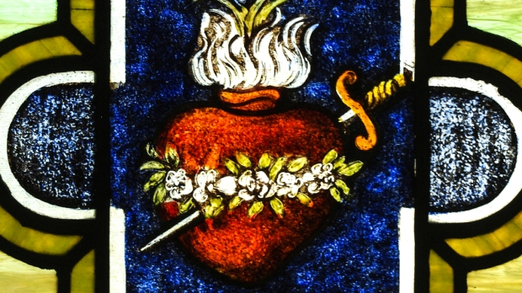
Devotion to the Immaculate Heart of Mary is an ancient custom, tied to a passage from the Gospel of Luke that speaks of Mary’s heart, “…(and a sword will pierce through your own soul also), that thoughts out of many hearts may be revealed” (Luke 2:35).
By the 17th century the devotion became more widespread and at about the same time images of Mary with her Immaculate Heart rose in popularity. The image appears to be simple, but the symbolism behind it is complex.
First of all, Mary’s heart is visible outside of her body. This points to her undying love for all people. Her love is such that she cannot contain it within. Some artists choose to depict the Blessed Virgin carrying her heart in her hand or simply pointing with a finger to her heart. The gesture suggests that Mary wants to give her heart to the one who is viewing the image.
Secondly, her heart is typically on fire, which emphasizes the intensity of her love for God and for humanity.
Next there are white roses that encircle her heart. These symbolize her purity, brought about by her Immaculate Conception, creating within her a most pure heart. In some cases, her heart is also shown with a lily coming out of the top, also symbolizing her purity.
A single sword is sometimes added going through her heart, referring to the passage of Luke (“…a sword shall pierce…”) and brings to mind the sorrows she endured during her lifetime, especially during the crucifixion.
Last of all, the heart is typically surrounded by rays of light. This brings to mind Revelation 12:1, where it describes the Blessed Virgin Mary as “a woman clothed with the sun.”

