Crucifix and Cross
http://www.signology.org/religious-symbols/catholic-symbols.htm
(article 7)

“Catholic Symbols - Different Crosses”
The Catholic Cross is without a doubt one of the most universally recognized symbols in the world! People from every nation and religion identify the cross as a symbol of Christianity and the Catholic church. Catholics everywhere wear their cross pendants or necklaces as outward symbols of their Christian faith.
Crucifix Symbols - Cross with three-dimensional model of Jesus being crucified, early versions were called 'Christus Rex' depicting Christ crowned and robed
Latin Cross Symbols - Also known as the Passion cross or Plain cross is recognized by its long, upright vertical bar. The horizontal bar sits below the top of the vertical bar.
Calvary Cross Symbols - This is a Latin cross mounted on three steps as its base, three steps are symbolic, the bottom step represents Charity, the middle step represents Hope and the top step represents Faith.
Celtic Cross Symbols - Also known as the Iona Cross has the addition of a circle to represent eternal life.

[Grab your reader’s attention with a great quote from the document or use this space to emphasize a key point. To place this text box anywhere on the page, just drag it.]
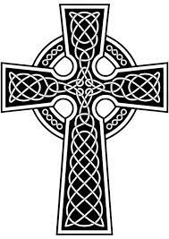
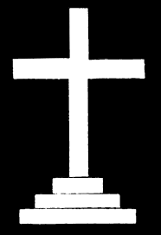
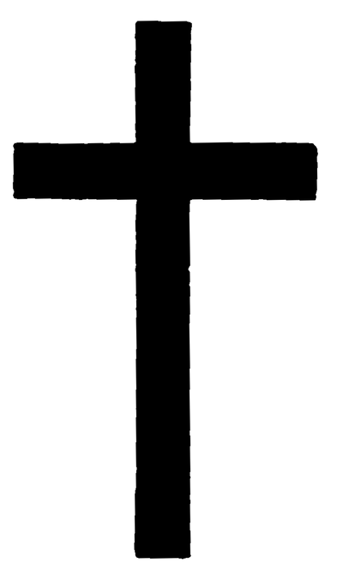
Latin Cross Calvary Cross Celtic Cross

