Crucifix and Cross
https://preachingsymbols.com/calvary-cross
(article 6)
“Symbolism of the Calvary Cross”

SYMBOLISM OF THE CALVARY CROSS
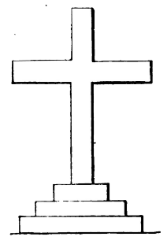

What does this Christian symbol mean?
The Calvary Cross is a Latin cross on three steps. The three steps are understood to symbolize the three cardinal virtues of Faith, Hope and Love (sometimes called charity).
Some have gone so far as to connect each virtue with a specific step, typically identifying faith as the top, and love as the bottom step.

Where can I find this Christian symbol?
Many free-standing Latin Crosses are actually Calvary Crosses because the three steps provide a built in stand. This makes it popular as a three dimensional sculpture, or for use on the table or altar (depending on your denomination).
​
These crosses are fairly common. If there are free-standing crosses in your worship space, look at them closely to see if they are actually Calvary Crosses - but keep in mind, a true Calvary Cross has exactly three steps. Often, what may have started out as a Calvary Cross will acquire additional steps over the years as well meaning clergy or parishioners try to adapt an old cross to a new space by increasing height or visibility.

