Crucifix and Cross
https://preachingsymbols.com/celtic-cross
(article 5)
“Symbolism of the Celtic Cross”

SYMBOLISM OF THE CELTIC CROSS
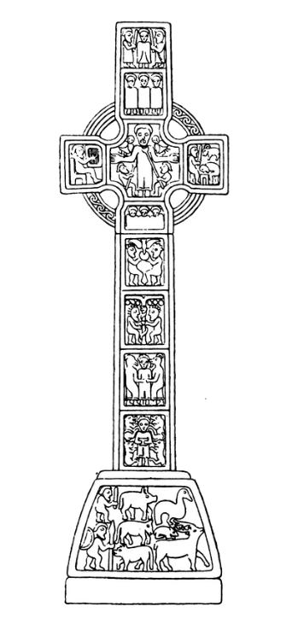

What does this Christian symbol mean?
A Celtic cross is often defined as any cross “which has a circle enclosing the cross beams” The Celtic cross may also be called an Irish Cross, a wheel cross, or a cross of Iona. There are several legends about the origin and thus symbolism of the Celtic Cross.

1. The Celtic cross began as a large, stone, Latin cross. Crosses in this style were sometimes wider at the ends than in the center, so gravity eventually took its toll, breaking one or both of the arms. Scultors discovered that it they could repair these crosses by reconnecting the arms to a ring, thus creating the familiar symbol of the Celtic Cross. If this is true, then the symbolism is fundamentally the same as the symbolism of the Latin cross.
​
2. St. Patrick is credited for bringing Christianity to Ireland around the year 440. In the process, he found people worshiping a deity with a circle as its symbol. St. Patrick explained to them that was not a god, but that the God who created the sun used a different symbol. He then etched a Latin cross over the circle, and told them the story of the crucifixion. The result was a Celtic Cross. This legend focuses the symbolism of the Celtic Cross on Christ as king.

​3. The third possibility is that the Celtic Cross actually developed as a form of the Chi Rho, and was not the result of a moment of inspiration, but of a slow process of artistic evolution. Thus the Celtic cross was born. In this case, the symbolism could focus more specifically on Jesus as Messiah.

Where can I find this Christian symbol?
Celtic Crosses have become very popular, even in secular art. They are particularly present in Reformed churches, and often serve as a wall crosses or chancel crosses. If you keep your eyes open, you'll find Celtic Crosses in many different places.

The Irish high crosses are also becoming increasingly popular in art, many of which rely on this basic shape. The Monasterboice cross, show on the left is an example of one such cross.

