Symbols of the Holy Spirit
https://owlcation.com/humanities/catholic-symbols
(article 38)

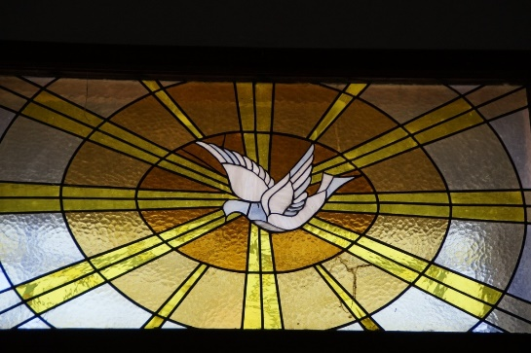

“The Dove”
The dove is a white bird often depicted in the Catholic Church as flying gracefully before a shining aura of light. Sometimes, the dove is carrying an olive branch in its beak.

What Is the Meaning of the Dove?
The dove is the symbol of the Holy Spirit. When Christ was baptized by John the Baptist, a dove descended on him, according to Matthew 3:16 and Mark 1:10. The dove is sometimes depicted with an olive branch in its mouth as a symbol of peace. It also symbolizes God's grace.
Do you remember when, in Noah's story, he sent out a dove to search for dry land after the rain stopped? It returned carrying an olive branch from the Mount of Olives, which was a sign and symbol of God's forgiveness.

