Papal Symbols (Symbols of the Pope)
https://spiritualray.com/most-recognizable-catholic-symbols-their-meanings
(article 35)

“Crossed Keys”
Crossed keys are symbols of the Pope’s authority. St. Peter who was considered to be the first Pope was promised the key to the kingdom of Heaven. A representation of the triple tiara combined with two crossed keys of Saint Peter continues to be used as a symbol of the papacy and appears on papal documents, buildings, and insignia.

“Papal Cross”
The triple cross, or the cross with three horizontal beams, is used as an emblem for the office of the Pope. One of the interpretations of the three crossbars, akin to the three bands of the tiara, is interpreted as teacher, lawmaker, and judge.

“Mitre and Staff”
The mitre, or the bishop’s cap, and staff are common symbols used in the Roman Catholic religion. It simply signifies the office of the pastoral staff.
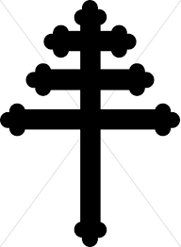

Crossed Keys Papal Cross Mitre and Staff
