Papal Symbols (Symbols of the Pope)
https://owlcation.com/humanities/catholic-symbols
(article 34)

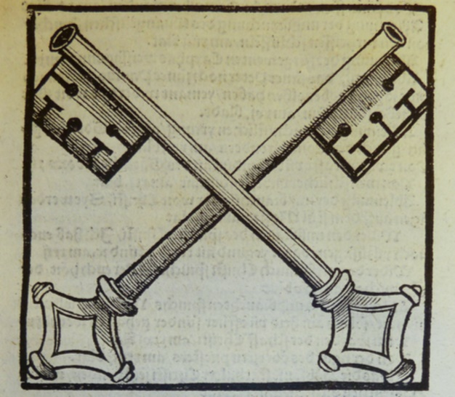

“Crossed Keys”
In Christian art, crossed keys, sometimes known as the Keys of Heaven, are a pair of keys that overlap and interlock, creating an "X." The keys are used as ecclesiastical heraldry, papal coats of arms, and symbolic images in holy places.

What Is the Meaning of the Crossed Keys?
The crossed keys represent the metaphorical keys that Jesus promised to St. Peter, empowering him to take binding actions in leading the institution of the Catholic Church. In short, they are a symbol of the Pope's authority. In the gospel of Matthew, Jesus says to Peter:
I will give you the keys to the kingdom of heaven, and whatever you bind on Earth shall be bound in heaven, and whatever you loose on Earth shall be loosed in heaven.

