Symbols of the Trinity
https://thecatholicspirit.com/commentary/hotdish/saint-patrick-the-shamrock-and-the-trinity/
(article 31)

“Saint Patrick, The Shamrock, and The Trinity”
Father Michael Van Sloun | March 16, 2011 | 0 Comments
Save
Share1
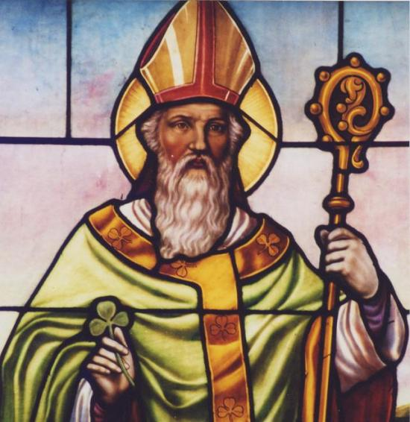
St. Patrick at St. Nicholas in Belle River

The shamrock is a symbol both for the Holy Trinity and St. Patrick (389-461). The shamrock is a clover plant with a yellow flower and leaflets made up of a stem with three small green leaves. The plant is very common and widely distributed throughout Ireland.
St. Patrick was a zealous missionary to the Irish, a people who upon his arrival in 432 had heard little or nothing of Jesus and his gospel. St. Patrick was an energetic traveler, a determined evangelizer, and a courageous preacher, and as he canvassed the countryside he was assailed by bitter opponents who threatened his life and undermined his message, but undeterred, he made hundreds and thousands of converts.
Whether St. Patrick was speaking to local pagans who knew nothing of the Christian faith, or to neophytes, newly-baptized disciples who were not well-grounded in the truths of the faith, he was faced with the daunting task of explaining profound mysteries such as the Trinity which are so difficult to understand.
There are several popular legends about how St. Patrick used the shamrock to explain the mystery of the Trinity. According to one story, St. Patrick went to Connaught where he met two of King Laoghaire’s daughters, Ethne and Fedelm. St. Patrick had been unable to persuade the king to convert, but he convinced the king’s daughters. During their time of instruction St. Patrick used a shamrock to visualize the mystery of the Trinity, how a single plant with three leaves is analogous to the one Triune God with three separate and distinct Persons (Thurston, H. J., ed., Butler’s Lives of the Saints, Vol. 1, 615).
According to another legend, St. Patrick used a shamrock to help explain the Trinity in a sermon he preached directly to King Laoghaire.
According to a third legend, St. Patrick was traveling and happened upon a number of Irish chieftains along a meadow. The tribal leaders were curious about the Trinity and asked St. Patrick for an explanation. So he bent down, picked a shamrock, and showed it to them, and explained how the three leaves are part of the one plant, and how similarly the three Persons, Father, Son, and Spirit, are part of one Supreme Being.

