Symbols of Jesus
https://owlcation.com/humanities/catholic-symbols
(article 26)
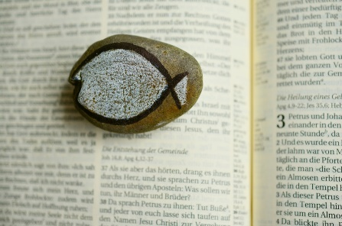

“The Fish also known as ICHTHUS/Ichthys”
One of the oldest Christian symbols is the fish. It was used by Christians to identify themselves and each other, often in times of persecution. It is often found in the Roman catacombs, a secret meeting place during the time when the Christians were persecuted for their faith by the Romans.

What Is the Meaning of the Fish?
The fish is based on an acrostic of the initial letters of the Greek words for Jesus Christ. To understand this symbol, you need to know the meaning of the acronym. The Greek word for fish is "Ichthus," which is also an acronym for Jesus. The Latin, "Iesous CHristos THeou Uios Soter" translates in English to, "Jesus Christ, Son of God, Saviour."
Christ also referred to his apostles as "Fishers of Men," while the early Christian fathers called the faithful "pisculi," which means "fish."

https://owlcation.com/humanities/catholic-symbols

“The Lamb”
One of the most important symbols of Christ is the Lamb. Jesus Christ as the Lamb of God is mentioned in John 1:35-36 and Revelation 5:6-14, and always in the words of the Mass.

What Is the Meaning of the Lamb?
The whiteness of the Lamb symbolizes innocence and purity. Lambs are also often associated with sacrifice in the Old Testament. Christ, the sacrificial lamb, died for the sins of humanity. The lamb can also symbolize subservience to God.
The lamb is sometimes portrayed with a flag. This is symbolic of Christ's victory over death in his resurrection.
