Symbols of Jesus
https://owlcation.com/humanities/catholic-symbols
(article 25)
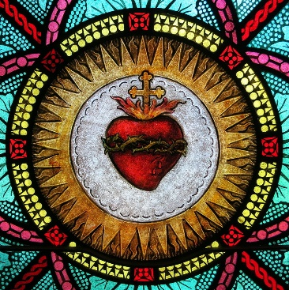

“The Sacred Heart”
In Catholic art, the Sacred Heart is usually depicted as a flaming heart. It is also usually shining with divine light, pierced (presumably from a lance), encircled by a crown of thorns, surmounted by a cross, and bleeding. Sometimes it is shown in the bosom of Jesus Christ. The wound, thorns, and blood represent Jesus' crucifixion, and the flames represent the transformative power of divine love.

What Is the Meaning of the Sacred Heart?
The Sacred Heart represents Jesus' physical heart and represents divine love. It is a devotional of Catholics everywhere and encapsulates the message of Jesus' long-suffering love and passion towards humanity. On its own, the heart is a symbol of love. But the Sacred Heart, pierced and wrapped in thorns, shows the depth of Jesus' love. It indicates that he was prepared to suffer and die for all people, and that his love is eternal.

