Greek and Latin Letters
https://preachingsymbols.com/chi-rho-%7C-xp
(article 23)
“Symbolism of Chi Rho/XP”

SYMBOLISM OF CHI RHO | XP
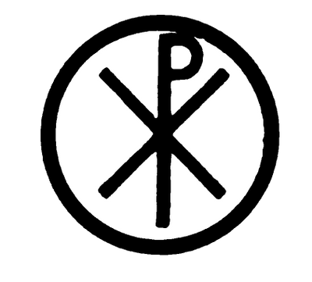

What does this Christian symbol mean?
The Chi Rho is a Christian symbol that looks like an X P. Pronounced Kie - Roe, it often appears to be a capital P overlaid on an x or t.
The Chi Rho is actually two Greek letters, the Chi, which corresponds roughly to the English letter C (or Ch) and the Rho, which corresponds roughly to the English R. These two letters are the first letters in the Greek word Christ. The Chi Rho is thus a monogram for Christ.
Some believe that the Chi Rho actually developed into the Celtic Cross, as seen in the image below (from John Allen's Early Christian Symbolism). For some history behind the Chi Rho, be sure to read about the Labarum.

Where can I find this Christian symbol?

Keep your eyes open! The Chi Rho appears in many places. Due to its small size, it is often incorporated in other images.

