Greek and Latin Letters
http://www.boston-catholic-journal.com/a-primer-to-catholic-symbolism.htm
(article 22)
Alpha and Omega
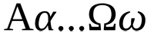

“The Alpha and the Omega — the Beginning and the End”

“I am Alpha and Omega, the first and the last, the beginning and the end.” (Apocalypse 22.13) The Name Jesus takes to Himself in the last book of the New Testament: the Apocalypse or the Book of Revelation

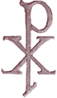

“The Chi Rho monogram”
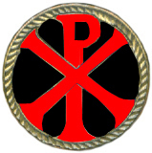

This is a Greek abbreviation of the title, “Christ”. “Chi” and “Rho” are the first two letters in the Greek word Christos or “Christ”.
In Greek capital letters they appear as “X” and “P”. In Greek Chiro, to anoint, and in Hebrew mashah denoted a cultic consecration. Through consecration, a king, a priest, a prophet, an altar were specially set part. The anointing would confer the Holy Spirit's power, making Him (Christ) the anointed one, in Hebrew, the Messiah of the Lord.
The New testament applies to Jesus the Old Testament texts concerning the anointing of the King-Priest. A priestly anointing was not narrated of Jesus, because He was the high priest, not like Aaron but according to the order of Melchizedek. While a prophetic anointing had been attributed to Jesus it was related to His baptism. Jesus is the anointed Messiah.

I.H.S. the Christogram

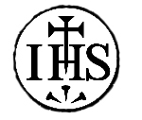

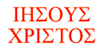
“The Christogram
I.H.S.”
A Christogram for the name of Jesus using the first three letters of the word in Greek. The Greek Christogram ΙΗΣΟΥΣ (IHSOUS) for Jesus, and in Latin Iesus Hominum Salvator, “Jesus Savior of mankind.”

