Greek and Latin Letters
https://owlcation.com/humanities/catholic-symbols
(article 21)

“INRI”

What Do the Letters "INRI" Stand for on the Cross?
A crucifix often has the letters "INRI" carved into the wood of the cross. These letters are short for the Latin phrase, "Iesus Nazarenus, Rex Iudaeorum," which translates to "Jesus of Nazareth, King of the Jews."
These are the words which Pontius Pilate, the Roman governor of Judea who sentenced Jesus to death, ordered to be written on the cross on which Jesus Christ was crucified.
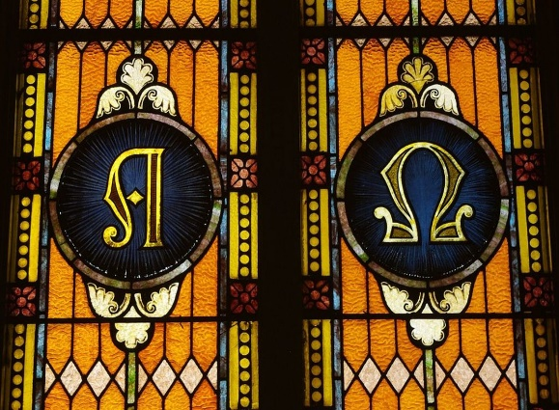
Alpha and omega depicted in stained glass at Saint Mary Catholic Church.
Wikipedia Commons, CC BY-SA 3.0

2. Alpha and Omega
Alpha and omega are the first and last letters of the Greek alphabet. They are used at various times in the Church liturgical year. The alpha and omega have been used by Catholics since the fourth century as symbols expressing the confidence of orthodox Christians in the scriptural proofs of God.

What Is the Meaning of Alpha and Omega?
In the book of revelation 22:13, Christ refers to himself as the alpha and the omega. That is, the first and the last. These two letters symbolize the fact that Christ is the beginning and the end of all creation.

“IHS and Chi-Rho”
The letters IHS often appear on liturgical items, building plaques, gravestones, and sacred vessels. IHS is a shortened form of the Greek word for Jesus, which is "IHΣΟΥΣ."
The letters X and P are often used as another symbol for Christ. The first two letters of Christ's name in Greek are X and P. In the Greek alphabet, X equals "CH," and P equals "R." Also known as the Chi-RhO cross, the letters are usually inscribed one over the other and are sometimes enclosed within a circle, becoming both a cosmic and a solar symbol.
