Symbols of the Blessed Mother
https://owlcation.com/humanities/catholic-symbols
(article 10)
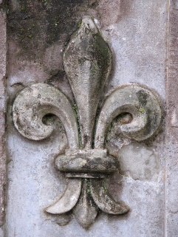

“Fleur-de-Lis”
The fleur-de-lis is a stylized lily composed of three petals bound together at their base. The lily has been used in many places throughout history, serving formerly as the emblem depicted on the royal arms of France (a historically Catholic nation), and has always represented divinity.

What Is the Meaning of the Fleur-de-Lis?
In one interpretation, the flower is a symbol of the Virgin Mary, the mother of Jesus. The whiteness and beauty of the lily is symbolic of the purity of Mary Immaculate.
In another interpretation, the lily depicts the Holy Trinity, which consists of the Father (God), the son (Jesus Christ), and the holy spirit–or one God in three divine persons. The band which hold the three pedals together represents Mary, since it was she who bore the child of God.

