Crucifix and cross
http://www.boston-catholic-journal.com/a-primer-to-catholic-symbolism.htm
(article 1)

“The Crucifix or Cross”
Probably the most recognized and most loved of the Christian symbols is the simple sign of the Cross with the Corpus Figure of Christ.
How many prisoners and captives have found solace and strength in beholding an indentation in the soil traced out as a cross, or have drawn upon a dirty window pane the form of the Cross, or even to of observed the crossing of two blades of grass, or branches of a tree?
How many soldiers far away from home who fell in battle, have had their mortal remains marked with a line of pebbles, or intertwined twigs forming the Cross of Christ?
Many people have been saved from suicide after having focused their attention upon a Cross, whether a man-made symbol or a sign within nature?
A simple Cross or Crucifix is a sign of salvation and hope, a reminder of the jewel of our Christian faith, we are also comforted in our belief in its power to defend us from evil and to overcome the great adversary, the devil and his demons.
We are, however, accustomed to consider the Sign of the Cross (Signum Crucis) as wholly a Christian symbol, originating with the crucifixion of our Redeemer. This is quite erroneous. In ancient Carthage it was used for ornamental purposes. Runic Crosses were set up by the Scandinavians as boundary marks, and were erected over the graves of Kings and heroes.
Cicero tells us that the augur's staff with which they marked out the heaven was a cross.
The ancient Egyptians employed the same as a sacred symbol, and we see on Greek sculptures, a cake with a cross.
It was also a sacred symbol among the Aztecs long before the landing of Cortez.
All this can be seen as a prefiguring, a preparation of humanity for the greatest Cross and Self- giving in love that the world would ever know, on Calvary.
It also adds weight to the fact, considering its primitive religious associations, that crucifixion was a deliberate mockery of the “gods”. The barbaric roman practice of crucifixion was for the lowest and most heinous crimes.
But by Christ’s sacrificial offering on Calvary, the hitherto sign of shame became a sign of glory.
In heraldry there are twelve different crosses.
The Cross as a mystic emblem can be reduced to these five:

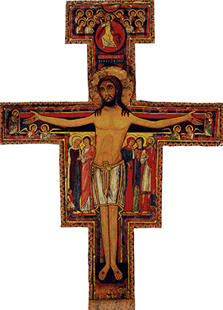
San Damiano Cross
of St. Francis of Assisi
Greek Cross    A Cross commonly  used as early as the  4th century  Latin Cross | St. Andrew’s Cross    A saltire (X-shaped) cross  upon which the  Apostle Saint Andrew  was crucified, considering  himself unworthy to be  crucified as Jesus was.
  Initially used solely by the  Catholic Church, it became  the universal sign of  Christianity. | Tau Cross    Also called the Cross of  Saint Anthony of Egypt

